**Lab 4**

Data: Collected data from different websites about acceptance rate, average living cost, average salaries after graduation and average quant score for the prospective students.

Claim: Though the average living cost I high in Santa Clara with the acceptance rate for the same quant score but average salaries after graduation is high in Santa Clara university.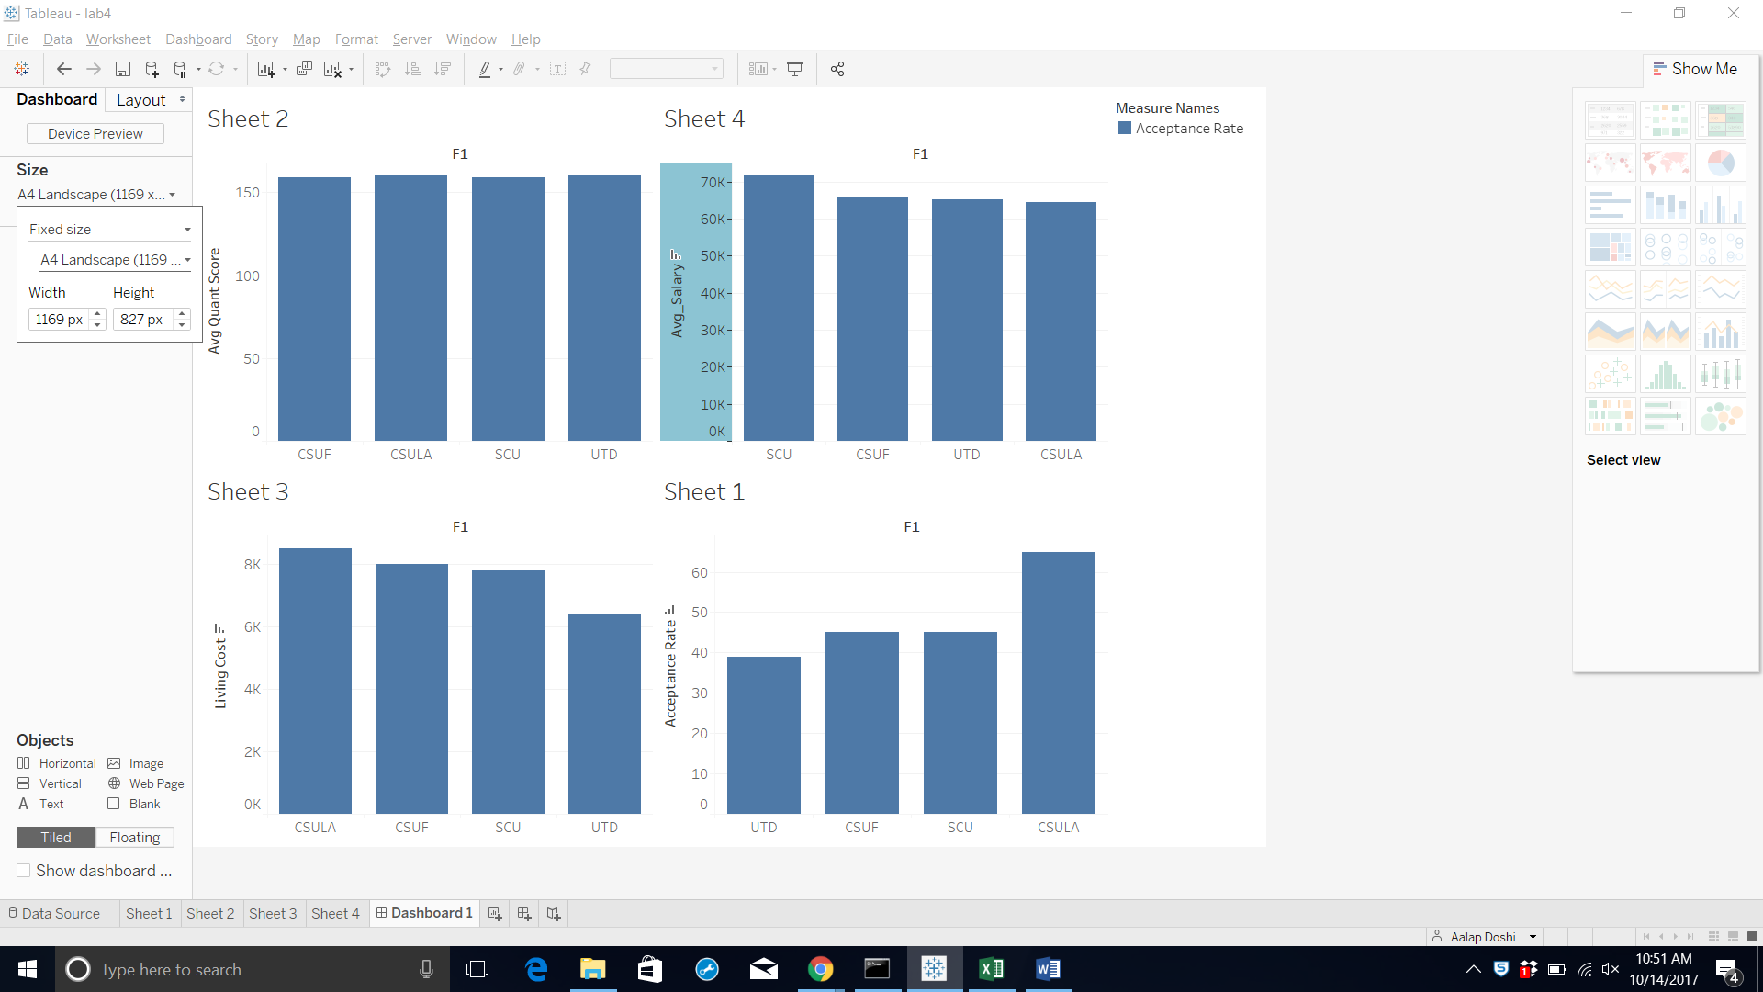

Qualifier: I have taken universities which have their average quant score around 160.

Warrant: Average salary for Santa Clara university comes out to 70K which is clearly more than other universities.

Reservations: What is the placement rate about the students getting placed after graduation. This doesn’t clearly specify about how many students actually complete their graduation and get places.